

# Internship Report

**On**

# Python With Data Science

# Laptop Price Prediction

# Submitted by Submitted to

# Rohit Agarwal Mallika Srivastava 22ETCCS140 Head, Training Delivery Techno India NJR Institute EISystems Services

# of Technology

# &

# Mayur Dev Sewak

# Head, Internships & Trainings

# EISystems Services

**Student’s Declaration**

I, Rohit Agarwal a student of B.Tech program, Roll No. 22ETCCS140 of the Department of CSE, Techno India NJR Institute of Technology College do hereby declare that I have completed the mandatory internship in Eisystems Technologies under the faculty guideship of Self, Department of CSE , Techno India NJR Institute of Technology.



03/05/2024

**Table of Content**

|  |  |  |
| --- | --- | --- |
| Serial No | Title | Page No |
| 1 | Cover page of report | 1 |
| 2 | Student declaration | 2 |
| 3 | List of Figures | 4 |
| 4 | List of Tables | 5 |
| 5 | Executive Summary | 6 |
| 6 | Overview of Organization | 7 |
| 7 | Project Summary | 8 |
| 8 | Process flow | 9 |
| 9 | Program with Supported Screenshots | 11 |
| 10 | Input / Output Datasets with Screenshots | 13 |
| 11 | Images | 14 |
| 12 | References | 15 |
| 13 | Student Self Evaluation | 16 |
| 14 | Annexure 1 (Daily Activity Report) | 17 |
| 15 | Annexure 2 (Weekly Activity Report) | 25 |

**List of Figures**

|  |  |  |
| --- | --- | --- |
| Serial No | Image Caption | Page No |
| 1 | Dataset | 10 |
| 2 | Pre-Process Data | 10 |
| 3 | Model Evaluation | 11 |
| 4 | Dataset | 12 |
| 5 | Dataset | 13 |
| 6 | Pre-Process Data | 13 |
| 7 | Model Evaluation | 13 |

**List of Tables**

|  |  |  |
| --- | --- | --- |
| Serial No | Table Caption | Page No |
| 1 | Daily Activity Report Week No: 1 | 16 |
| 2 | Daily Activity Report Week No: 2 | 17 |
| 3 | Daily Activity Report Week No: 3 | 18 |
| 4 | Daily Activity Report Week No: 4 | 19 |
| 5 | Daily Activity Report Week No: 5 | 20 |
| 6 | Daily Activity Report Week No: 6 | 21 |
| 7 | Daily Activity Report Week No: 7 | 22 |
| 8 | Daily Activity Report Week No: 8 | 23 |
| 9 | Weekly Progress Report | 24 |

**Executive Summary**

During the period of March 5th to April 31st, I undertook a comprehensive internship with EISystems Services, specializing in Python with a focus on data science. Throughout the two-month duration, I engaged in rigorous training, project development, and practical application of skills. The internship encompassed the creation of eight projects, with one centered on Python programming and the remaining seven dedicated to various aspects of data science.

The training phase of the internship was structured to provide a foundational understanding of Python programming language and its applications in the field of data science. Through hands-on exercises, tutorials, and mentorship, I gained proficiency in utilizing Python libraries such as Pandas, NumPy, Matplotlib, and Scikit-learn for data analysis, visualization, and machine learning tasks.

Each of the eight projects undertaken during the training phase served as a testament to the acquired skills and knowledge. From exploratory data analysis to predictive modeling, these projects demonstrated my ability to apply Python programming and data science techniques to solve real-world problems effectively. The projects covered diverse domains, showcasing versatility and adaptability in utilizing data-driven approaches.

Following the training phase, a larger project was undertaken to further consolidate the skills and concepts learned. This project involved the integration of advanced data science techniques to address a complex problem statement, showcasing proficiency in project management, problem-solving, and critical thinking.

Overall, the internship experience at EISystems Services has been enriching and rewarding. It provided an excellent platform to enhance my proficiency in Python programming and data science, equipping me with valuable skills essential for success in the field. The combination of theoretical learning, practical application, and project-based approach has significantly contributed to my professional development and preparedness for future endeavors in data science and related domains.

**Overview of Organization**

Introduction of the Organization:

EISystems Services is a leading technology firm dedicated to providing innovative solutions in the field of information technology. Established with a vision to revolutionize the digital landscape, EISystems Services has emerged as a trusted partner for businesses seeking cutting-edge technology solutions. With a focus on excellence and customer satisfaction, the organization strives to deliver superior services tailored to meet the diverse needs of its clientele.

Vision, Mission, and Values of the Organization:

- Vision: EISystems Services envisions becoming a global leader in technology innovation, driving digital transformation across industries.

- Mission: The mission of EISystems Services is to deliver exceptional technology solutions that empower businesses to thrive in the digital age, fostering growth, efficiency, and sustainability.

- Values: The core values of EISystems Services include integrity, innovation, collaboration, and customer-centricity. These values serve as guiding principles, shaping every aspect of the organization's operations and interactions.

Policy of the Organization, in relation with the intern role:

EISystems Services is committed to nurturing talent and fostering a culture of learning and growth. As part of its internship program, the organization provides interns with hands-on experience, mentorship, and opportunities for professional development. Interns are encouraged to actively engage in projects, contribute innovative ideas, and collaborate with team members to achieve organizational objectives. EISystems Services values the contributions of its interns and strives to create an inclusive and supportive environment where individuals can thrive and excel in their roles.

**Project Summary**

**Idea behind making this project:**

The idea behind developing the laptop price prediction project stemmed from the growing demand for accurate pricing models in the consumer electronics market. With the proliferation of laptop models offering diverse features and specifications, consumers often face challenges in determining fair prices for their desired configurations. This project aimed to leverage machine learning techniques to develop a predictive model capable of estimating laptop prices based on relevant attributes.

**About the project:**

The laptop price prediction project involved the collection and analysis of data pertaining to various laptop models, including specifications such as processor type, RAM capacity, storage capacity, display size, and brand. The dataset was meticulously curated to ensure accuracy and relevance, encompassing a wide range of laptops from different manufacturers and price points.

**Software used in project:**

The project utilized Python programming language along with popular libraries such as Pandas, NumPy, Scikit-learn, and Matplotlib for data preprocessing, feature selection, model training, and evaluation. Jupyter Notebook served as the primary development environment, offering an interactive platform for code execution and analysis.

**Technical apparatus requirements before making this project:**

Prior to initiating the project, the technical apparatus requirements included access to a suitable computing environment with sufficient processing power and memory to handle data preprocessing and model training tasks efficiently. Additionally, a reliable internet connection was necessary for data acquisition and research purposes.

**Result or Working of project:**

The laptop price prediction project resulted in the development of a robust machine learning model capable of accurately estimating laptop prices based on input features such as specifications and brand. The model demonstrated promising performance metrics, including high accuracy and low error rates, validating its effectiveness in predicting laptop prices with confidence.

**Process Flow**

**1. Data Collection:**

- Input: Data on laptop specifications and prices from various sources such as online retailers, manufacturers, and market research firms.

- Process: Gather data using web scraping techniques or obtain datasets from reliable sources.

- Output: Raw dataset containing attributes such as processor type, RAM capacity, storage capacity, display size, brand, and corresponding prices.

**2. Data Preprocessing:**

- Input: Raw dataset.

- Process:

- Handle missing values: Impute missing values or remove incomplete records.

- Feature engineering: Extract relevant features, encode categorical variables, and normalize numerical features.

- Output: Cleaned and processed dataset ready for model training.

**3. Model Training:**

- Input: Cleaned dataset.

- Process:

- Split dataset: Divide data into training and testing sets for model evaluation.

- Select model: Choose appropriate machine learning algorithm (e.g., linear regression, random forest) for price prediction.

- Train model: Fit the selected model on the training data to learn the underlying patterns.

- Output: Trained machine learning model capable of predicting laptop prices based on input features.

**4. Model Evaluation:**

- Input: Trained model, testing dataset.

- Process:

- Predict prices: Use the trained model to predict laptop prices on the testing data.

- Evaluate performance: Calculate evaluation metrics such as mean squared error, mean absolute error, and R-squared to assess the model's accuracy and generalization ability.

- Output: Performance metrics indicating the effectiveness of the predictive model.

**5. Deployment:**

- Input: Trained model, new laptop specifications.

- Process:

- Input new data: Collect specifications of a new laptop for price estimation.

- Preprocess data: Apply the same preprocessing steps as done during training.

- Predict price: Utilize the trained model to predict the price of the new laptop.

- Output: Estimated price of the new laptop based on its specifications.

The code implementation would reflect the above process, incorporating functions and modules for data collection, preprocessing, model training, evaluation, and deployment. Each step would be clearly defined and executed sequentially to ensure a smooth flow from input to output, capturing all conditions and decisions involved in the process.

**Program with Supported Screenshots**

Screenshots:

1. Dataset:

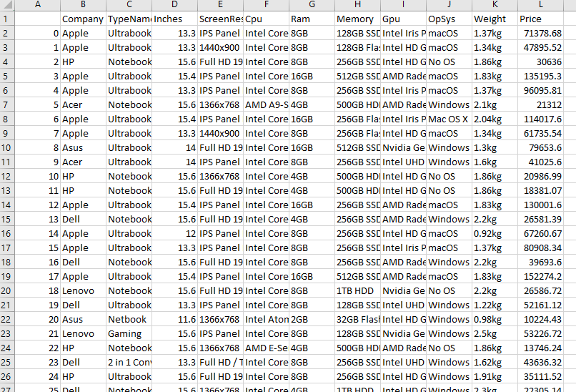

1. Pre-processed Data:

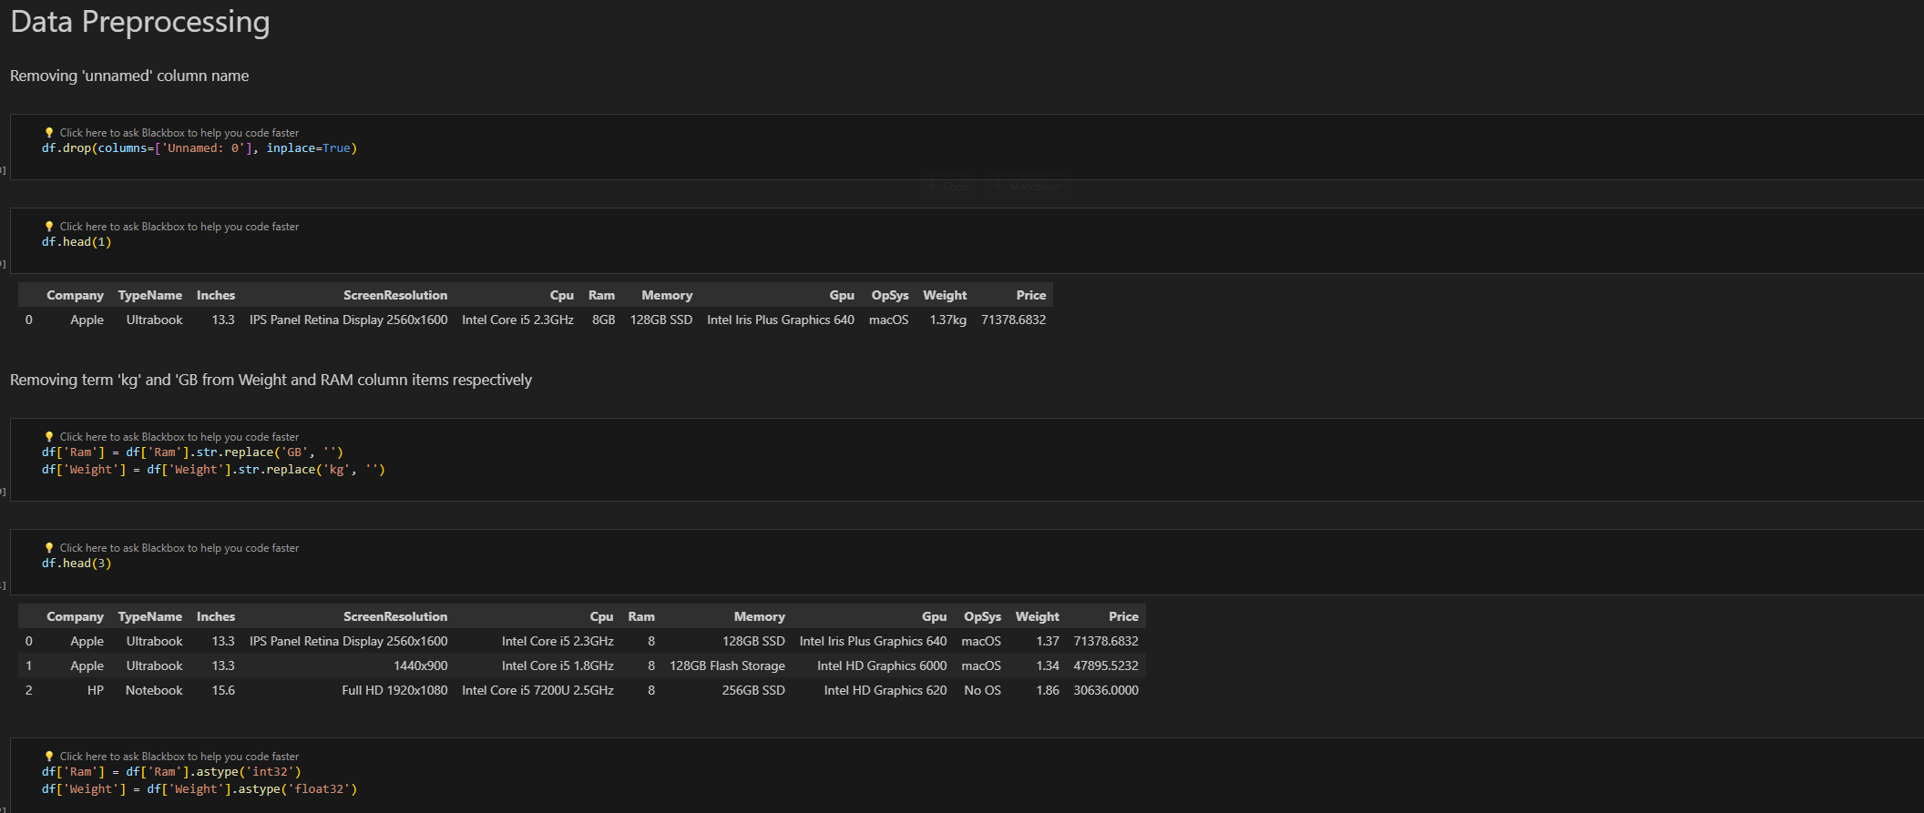

1. Model Evaluation:

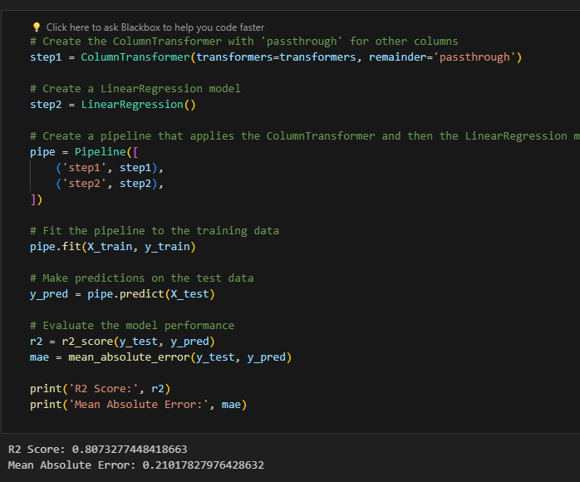

**Input / Output with Datasets & Supported Screenshots**

Input:

* Dataset containing laptop specifications (laptop_data.csv)

Output:

* Predicted prices for a sample of laptops based on their specifications

Screenshot 1: Dataset (laptop_data.csv)



**Images**







**References**

* 1. "About Us - EISystems Services." EISystems Services. [Online]. Available:

[www.eisystems.in/about.php](http://www.eisystems.in/about.php)

* 1. Python Software Foundation. Python Programming Language. [Online]. Available:

<https://www.python.org/>

* 1. Pandas Documentation. [Online]. Available:

<https://pandas.pydata.org/docs/>

* 1. Scikit-learn Documentation. [Online]. Available:

<https://scikit-learn.org/stable/documentation.html>

* 1. Matplotlib Documentation. [Online]. Available:

<https://matplotlib.org/stable/contents.html>

* 1. "Machine Learning Algorithms - A Review," B. G. Glorot et al., CoRR, abs/1408.4410, 2014.
  2. "The Elements of Statistical Learning: Data Mining, Inference, and Prediction," T. Hastie, R. Tibshirani, and J. Friedman, Springer, 2009.

**Student *Self Evaluation of the Short-Term Internship***

**Please rate your performance in the following areas:**

|  |  |  |  |  |  |
| --- | --- | --- | --- | --- | --- |
| **1) Oral communication** | **1** | **2** | **3** | **4** | **5** |
| **2) Written communication** | **1** | **2** | **3** | **4** | **5** |
| **3) Initiative** | **1** | **2** | **3** | **4** | **5** |
| **4) Interaction with staff** | **1** | **2** | **3** | **4** | **5** |
| **5) Attitude** | **1** | **2** | **3** | **4** | **5** |
| **6) Dependability** | **1** | **2** | **3** | **4** | **5** |
| **7) Ability to learn** | **1** | **2** | **3** | **4** | **5** |
| **8) Planning and organization** | **1** | **2** | **3** | **4** | **5** |
| **9) Professionalism** | **1** | **2** | **3** | **4** | **5** |
| **10) Creativity** | **1** | **2** | **3** | **4** | **5** |
| **11) Quality of work** | **1** | **2** | **3** | **4** | **5** |
| **12) Productivity** | **1** | **2** | **3** | **4** | **5** |
| **13) Progress of learning** | **1** | **2** | **3** | **4** | **5** |
| **14) Adaptability to organization’s culture/policies** | **1** | **2** | **3** | **4** | **5** |
| **15) OVERALL PERFORMANCE** | **1** | **2** | **3** | **4** | **5** |

**Rating Scale:** 5 will be Best while 1 will be Worst



**Signature of the Student**

**Annexure 1**

**Daily Activity Report**

Week No: 1

|  |  |  |  |
| --- | --- | --- | --- |
| Day & Date | Brief Description of Daily Activity | Learning Outcome | Person In-Charge |
| Day 1 | Introduction to Python Programming | Understanding the importance and applications of Python programming language. |  |
| Day 2 | Installation of Python | Learning how to install Python on different operating systems. |  |
| Day 3 | Execution Steps, Interactive Shell | Exploring the different ways to execute Python code, including interactive shell and command-line execution. |  |
| Day 4 | User Interface or IDE | Introduction to Python Integrated Development Environments (IDEs) and selecting suitable IDEs for development. |  |
| Day 5 | Creating Your First Python Program | Writing and executing a simple Python program to understand the basic syntax and structure of Python code. |  |

**Annexure 1**

**Daily Activity Report**

Week No: 2

|  |  |  |  |
| --- | --- | --- | --- |
| Day & Date | Brief Description of Daily Activity | Learning Outcome | Person In-Charge |
| Day 1 | Memory Management and Garbage Collection | Understanding how Python manages memory and handles garbage collection to optimize memory usage. |  |
| Day 2 | Object Creation and Deletion | Learning about object creation and deletion in Python, including dynamic memory allocation and deallocation. |  |
| Day 3 | Object Properties, Data Types and Operations | Exploring different data types in Python and performing operations such as arithmetic, comparison, and logical. |  |
| Day 4 | Numbers, String Operations | Working with numeric data types and string manipulation operations in Python. |  |
| Day 5 | List, Tuple | Understanding list and tuple data structures in Python, including creation, indexing, slicing, and methods. |  |

**Annexure 1**

**Daily Activity Report**

Week No: 3

|  |  |  |  |
| --- | --- | --- | --- |
| Day & Date | Brief Description of Daily Activity | Learning Outcome | Person In-Charge |
| Day 1 | Functions | Introduction to functions in Python, defining functions, and understanding their importance in code organization. |  |
| Day 2 | Function Definition and Call, Function Scope | Exploring function definitions, calling functions, and understanding variable scope within functions. |  |
| Day 3 | Function Arguments | Learning about function arguments, including positional arguments, keyword arguments, and default values. |  |
| Day 4 | Modules and Packages | Understanding modules and packages in Python, organizing code into reusable modules and structuring packages. |  |
| Day 5 | Module Creations and Usage, Types of Package in Python | Creating and using modules, exploring different types of packages in Python, and understanding their usage. |  |

**Annexure 1**

**Daily Activity Report**

Week No: 4

|  |  |  |  |
| --- | --- | --- | --- |
| Day & Date | Brief Description of Daily Activity | Learning Outcome | Person In-Charge |
| Day 1 | Classes | Introduction to classes in Python, defining classes, and understanding the concept of objects and instances. |  |
| Day 2 | Classes and Instances | Working with class instances, accessing attributes and methods, and understanding instance variables. |  |
| Day 3 | Classes Method Calls | Invoking methods on class instances and understanding the concept of method calls in Python. |  |
| Day 4 | Class Methods, Instance Methods | Differentiating between class methods and instance methods, and understanding their respective use cases. |  |
| Day 5 | Static Methods | Exploring static methods in Python, understanding their role and usage in class definitions. |  |

**Annexure 1**

**Daily Activity Report**

Week No: 5

|  |  |  |  |
| --- | --- | --- | --- |
| Day & Date | Brief Description of Daily Activity | Learning Outcome | Person In-Charge |
| Day 1 | Statements and Syntax | Understanding Python statements, syntax rules, and the importance of proper indentation. |  |
| Day 2 | Assignments, Expressions and Prints | Learning about assignments, expressions, and print statements in Python, and their usage in code. |  |
| Day 3 | If tests and Syntax Rules | Exploring if statements, conditional tests, and syntax rules for writing conditional expressions in Python. |  |
| Day 4 | While and For Loops | Working with while and for loops in Python, understanding looping constructs and their applications. |  |
| Day 5 | File Operations | Introduction to file handling in Python, including opening, reading, writing, and closing files. |  |

**Annexure 1**

**Daily Activity Report**

Week No: 6

|  |  |  |  |
| --- | --- | --- | --- |
| Day & Date | Brief Description of Daily Activity | Learning Outcome | Person In-Charge |
| Day 1 | OOPs concept | Understanding Object-Oriented Programming (OOP) concepts such as abstraction, encapsulation, and polymorphism. |  |
| Day 2 | Abstraction, Encapsulation | Exploring abstraction and encapsulation principles in OOP, and understanding their significance in code design. |  |
| Day 3 | Polymorphism | Learning about polymorphism and its types in Python, including method overriding and method overloading. |  |
| Day 4 | Inheritance | Introduction to inheritance in OOP, understanding inheritance hierarchy, and implementing inheritance in Python. |  |
| Day 5 | Types of Inheritance | Exploring different types of inheritance such as single, multiple, multilevel, and hierarchical inheritance. |  |

**Annexure 1**

**Daily Activity Report**

Week No: 7

|  |  |  |  |
| --- | --- | --- | --- |
| Day & Date | Brief Description of Daily Activity | Learning Outcome | Person In-Charge |
| Day 1 | Exception Handling | Introduction to exception handling in Python, handling errors and exceptions gracefully in code. |  |
| Day 2 | Default Exception Handler | Understanding the default exception handler in Python and its role in error handling. |  |
| Day 3 | Except Exceptions | Using the 'except' statement to catch specific exceptions and handle them appropriately. |  |
| Day 4 | Raise an Exception | Learning how to raise custom exceptions in Python, creating and raising exceptions based on specific conditions. |  |
| Day 5 | User Defined Exception | Creating custom exception classes in Python to handle application-specific errors. |  |

**Annexure 1**

**Daily Activity Report**

Week No: 8

|  |  |  |  |
| --- | --- | --- | --- |
| Day & Date | Brief Description of Daily Activity | Learning Outcome | Person In-Charge |
| Day 1 | Accessing Internet Data with Python | Exploring various methods to access internet data using Python, including web scraping and APIs. |  |
| Day 2 | Manipulating XML with Python | Introduction to XML parsing in Python, reading, writing, and manipulating XML data using Python libraries. |  |
| Day 3 | Activities & Project Discussion | Discussion on various activities and projects related to Python programming and Data Science. |  |
| Day 4 | Installing Different Libraries of Python | Practical session on installing and managing different Python libraries using package managers. |  |
| Day 5 | Project Discussion | Brainstorming and planning for project work, selecting project topics, and dividing tasks among team members. |  |

**Annexure 2  
Weekly Progress Report**

|  |  |
| --- | --- |
| Week(s) | Summary of Weekly Activity |
| Week 1 | Introduction to Python programming language, installation, execution steps, and creating first program. |
| Week 2 | Memory management, data types, object properties, and introduction to lists and tuples. |
| Week 3 | Functions, modules, classes, and instance methods. |
| Week 4 | Statements, syntax, file operations, and loops. |
| Week 5 | OOPs concepts, exception handling, accessing internet data, and manipulating XML with Python. |
| Week 6 | Revision of Python programming, introduction to machine learning, and overview of Data Science. |
| Week 7 | Working with Python libraries for Data Science, data analysis, and applying algorithms on datasets. |
| Week 8 | Understanding machine learning algorithms, working with datasets, and discussing projects for implementation. |